# North West Fungus Group

# 2025 Foray Recording Programme: -

# in association with the British Mycological Society

Contact Foray Leader if unsure about the weather/ terrain/access/cancellations. Read Risk assessment. Cover arms/legs against ticks, checking for them after; consider insect repellant; carry whistle or mobile phone. Planned changes will be notified by email.Most events start on **Sundays** promptlyat **10.30** (ie arrive before) and continue into the afternoon with a pause for refreshments over lunchtime. Beginners are welcome at A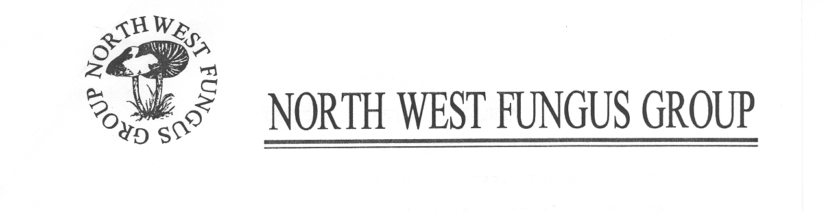LL forays.Please note that forays may not be suitable for small children. **No Dogs.**

**Saturday 22nd February: AGM**

**Risley Moss, north Warrington: SJ664920.** Access from M62 Jct 11. Continue along A574 to first island, turn left. Reserve signposted. 1**0am** (Coffee) for **10.30**. **WA3 6QX.** Guest Speaker Fay Voller, EHUni. Social gathering or foray 13.30 to 15.00.

**9th March –Gawthorpe Hall, Padiham, SD804 339**

**Meet at 10.00.** From M65 take Junction 10(from east) or 8(from west) . Follow A671 towards Padiham for about 2 miles. Right into South drive and immediately sharp right again into Stockbridge drive. Follow to the end. Car park on the left. Toilets will be opened up for us. W3W: SWORDFISH. CHROMATIC. SPORTS

**BB12 8SQ**: Leaders Steve Hurley (07816 932296) /John Watt (07768 043 461)

**30th March –** **Low** **Park Wood/ Sizergh SD503 878** Leave A591 west on A590 and after 500m cross over dual carriageway onto Nannypie Lane passing Strickland Arms and after going under A590, sharp left to Lower Sizergh Barn and park just beyond, **LA8 8AE.**

Leaders - Kerstin/ John W (07768 043 461)

**Saturday 24th May – Saturday Introduction to Fungi & Identification workshop. Risley Moss, nr Warrington (WA3 6QX).**  10 to mid-afternoon. Bring packed lunch. Access from M62 Jct 11. Continue along A574 to first island, turn left. Reserve signposted. Limited numbers so book early with Jeanette Maddy (07648 838946) *£10.00 non-members.*

**Saturday 28th June - Microscopy - Beginners’**

**Workshop, Risley Moss, nr Warrington (WA3 6QX).**  10 to mid-afternoon. Bring packed lunch. Access from M62 Jct 11. Continue along A574 to first island, turn left. Reserve signposted. Limited numbers so book early with Jeanette Maddy (07648 838946)  *£10.00 non-members.*

**Saturday 26th July Microscopy Improvers’ Workshop, Risley Moss, nr Warrington (WA3 6QX).** 10 to mid-afternoon. Bring packed lunch. Must bring your m’scope +/- spore print /fungi. Number limited so book early withJeanette Maddy (07648 838946)  *£10.00 non-members.*

**10th August**

**Eaves Wood, Silverdale:**

**SD 471 759 for lichens and fungi.**

Leaders; Allan Pentecost, John Watt (07768 043 461), Kerstin Nagel.

**7th September**

**Erddig –**

Leaders: John Ratcliffe and Clive Garnett

**14th September**

**Brookside/ Bury Meadows, SD723 277,**

Leaders Steve Hurley (07816 932296) /John Watt (07768 043461)

**28tth September**

**Tandle Hill**

**SD906 087**. Leader Ali McKernan *(07919 282914)*

**5th October**

**Lindow Moss SJ83 3814**

leaders: Jeanette Maddy / Tom Ferguson

**12th October**

**Nant Mill, nr Wrexham**

John Ratcliffe, Clive Garnett.

**19th October**

**Ainsdale NNR,** Tim Rogers

**26th October “Beginners’ Foray” Wigg Island Community Park, Runcorn.**

Leader Paul Hamlyin 0161278 7322 / 07904 459280)

**2nd November**

**Black Beck Wood SD338 860**

Leaders: Anne Horne/ John Watt

**9th November**

**Dunham Massey**

Leader: Jeanette Maddy (07648 838946)

**16th November:**

**Stanley Bank Wood, St Helens. SJ535 966** **WA11 0AB**. Leader **-** Tom Ferguson

Some other national events of interest in 2024 include:

**BMS Spring Field Meeting, 31st - 6th April Norfolk**

**BMS coprinoid workshop, 11-14th Sept..**

**National Fungus Day. Sat/Sunday 3/4th October 2025**

**BMS Autumn foray, Galloway,**

6th - 13th October

Joint foray with Isle of Man fungus group 24-27th October (fully booked)

**About the North West Fungus Group**

The North West Fungus Group is a regional group aiming to promote an interest in fungi across the counties of Cheshire, Lancashire, Greater Manchester, Merseyside, Cumbria and North Wales. Membership benefits include:-

* two newsletters per year
* Recording forays and special events
* Outreach activities centering around National Fungus Day
* short talk at the AGM
* microscopy instruction

**Membership** Individual membership - £7.50

* Family membership - £10.00 Members joining after November 1st will receive membership for the following year. **Membership Form available on website or from Secretary.**

***Chair:*** Jeanette Maddy *(*07548 838946)

***Membership Secretary:*** *Kerstin Nagel,*

*12 Cove Drive, Silverdale LA5 0SD*

***The NORTH WEST FUNGUS GROUP***

[**https://northwestfungusgroup.com/**](https://northwestfungusgroup.com/)



<https://www.facebook.com/groups/NorthWestFungusGroup/> register here

